Help me create PRD for this UI. The design uses a modern, gradient‑driven aesthetic with rounded cards, clear typography and numerous call‑to‑action buttons.

Requirements:
Login/Signin page
Functionality:
login in, creating a new account.
login in with email and password initially and adding later google, facebook, linkedin options.

#### ELEMENTS ####
Side Navigation bar:
- Dashboard
- Campaigns
- Resumes
- Cover Letters
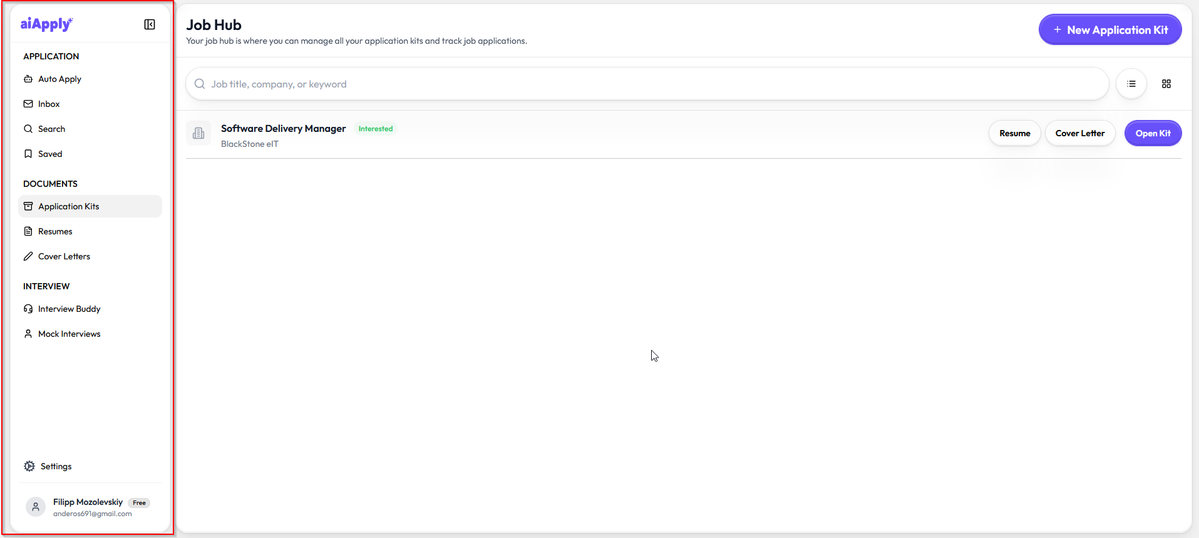

Dashboard Page:
Overall statistics. E.g Number of active campaigns, jobs found, jobs applied… last jobs applied… line graph with activity per day.

Campaigns page:
List of all campaigns and a link to create a new one.
This page should have these campaign details:
- Name
- Owner
- Location
- Jobs found
- Last search
- View, Edit, Delete (buttons)
Add/Edit Campaign page:
This page should have all the campaign details and possibility to edit them.

Campaign Details page:
When choosing a campaign, user should be transferred to the Campaign Details page. It should have some short campaign statistics on the top and all jobs below the statistics.
On this page user will be managing jobs: adding/creating CV’s and Cover letters, keeping track of job application status.
There should be filtering by job status, posted at
Campaign statistics should have:
- Status (Paused) and button find jobs. When user pushes button, we should show a loading animation and status should change depending on pipeline status(looking for jobs/ processing jobs/ ranking jobs / preparing results)
- Jobs Processed (number of jobs applied / all jobs presented)
- Last Update
Each job should have these fields:
- Company logo + Company Name (with a link to Glassdoor if we have one)
- Job Posting title (with a link to the application)
- Rank with number and explanation by clicking on it (bad fit, moderate fit, good fit, perfect fit)
- Posted At (when job was posted)
- Posting Current Status (found/preparing to apply/applied/waiting for reply/rejected(by user)) (user should be able to change the status)
- Approve/Reject Action button (if user click approve, status changes to preparing to apply, if reject, it disappears from the list, and the next runs don’t add this posting to the list)
- Resume and Cover Letter status(No/generated)
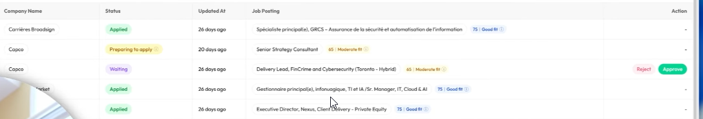
Job Details page
When user chooses a job, the website should be redirected to the Job Details Page.
This page should have:
- Resume (possibility to add a resume for each job to keep track which resume was used)
- Cover Letter (possibility to add/generate a cover letter for each job to keep track which resume was used)
- Comments (possibility to see and to add comments for each job posting to keep track of details, e.g. who was a reference person)
- job status history

